**Instructions for Non-VA Participants to Create a TMS Account and Obtain CE Certificates**

Non-VA Participants complete and follow steps highlight blue

**Conference Name:** Beyond the Caregiver Role: Seeing the Whole Caregiver

**Conference ID**: 4658119

**Conference Start Date** May 15, 2024 8:30am-11:30am

**Conference Location** Portland VA Auditorium 3710 SW US Veterans Hospital Rd 2nd Floor Portland, Oregon

**TMS Scheduled Offering** # 4658119

**VA Location:** Portland VA

Thanks for your interest in this VA educational program. VA manages and tracks all training and CEs through the online Talent Management System (TMS). To attend and receive your CE certificate, you’ll need to go online and complete information to create and account in TMS.

Thanks, in advance, for your patience with this new process. If you have questions or need assistance, please feel free to contact your ***VA POINT OF CONTACT*** *Yvette D. Arey,* [*Yvette.Arey@va.gov*](mailto:Yvette.Arey@va.gov) *or Miranda Bass* [*Miranda.Bass@va.gov*](mailto:Miranda.Bass@va.gov)

**For Non-VA Participants:**

**STEP 1: Create an account in TMS.**

Instructions:

1. To access the TMS, you must use one of the following browsers:

* Internet Explorer (11.0 and above)
* Mozilla Firefox (3.6.x.x and above)
* Safari on Mac (6.0 and above)
* Google Chrome (23.0.x.x and above)

1. Go to the TMS homepage (<https://www.tms.va.gov/SecureAuth35/>) and click ***Create New Non-Employee User*** to set up a TMS profile. If you’ve previously created a TMS account, if you have any questions about the information to be provided or experience difficulties creating a profile, contact the Enterprise Service Desk (ESD) at 1.855.673.4357

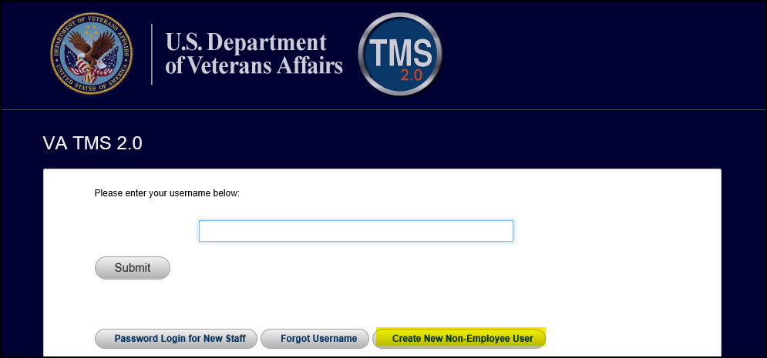

1. Select **Veterans Health Administration (VHA)** and click **Next**

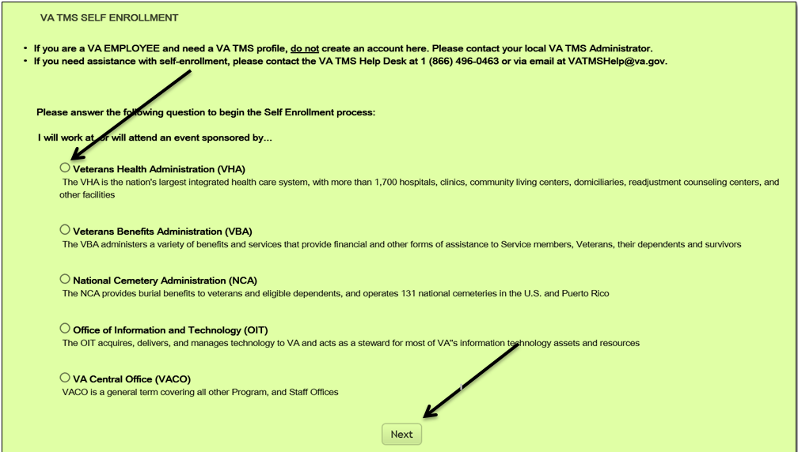

1. Select ***Conference Attendee (Those attending a VA-sponsored conference)*** and click ***Next***

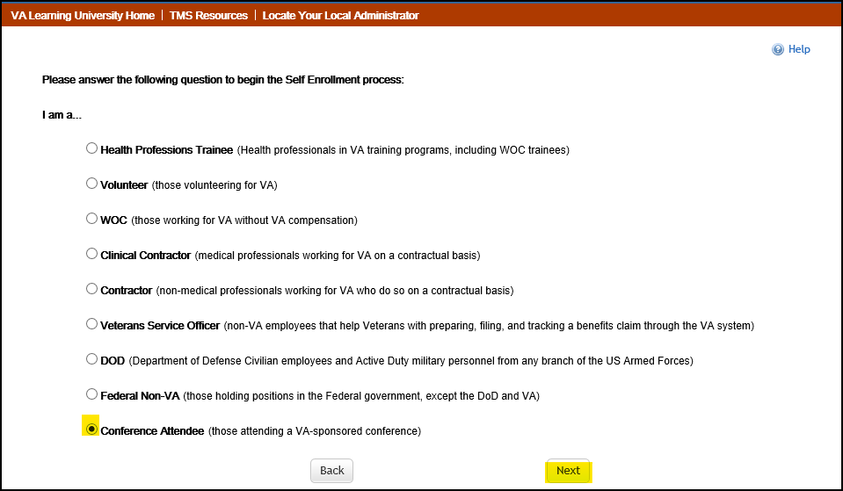

1. You must provide information with red asterisks.

**Note:** The **Email Address** that you enter here will be used as your Username to log into the system. Please ensure that the email address you use is one which you will be able access.

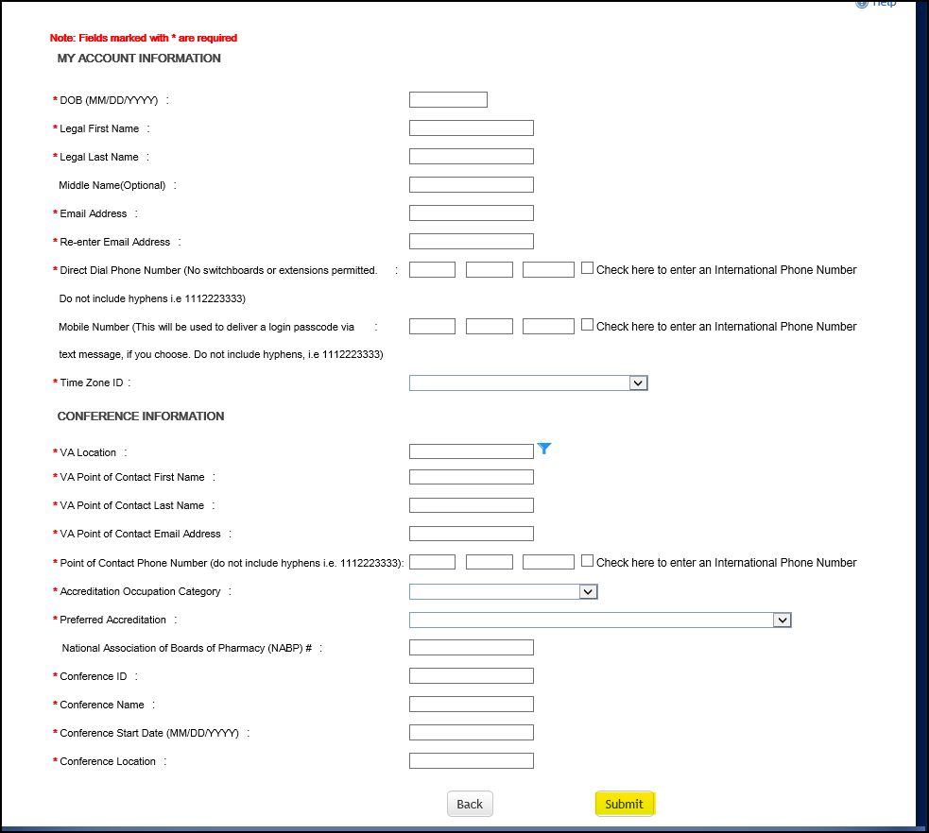

Note: The VA Location, VA Point of Contact and all conference information are listed on the top of page 1 highlighted yellow

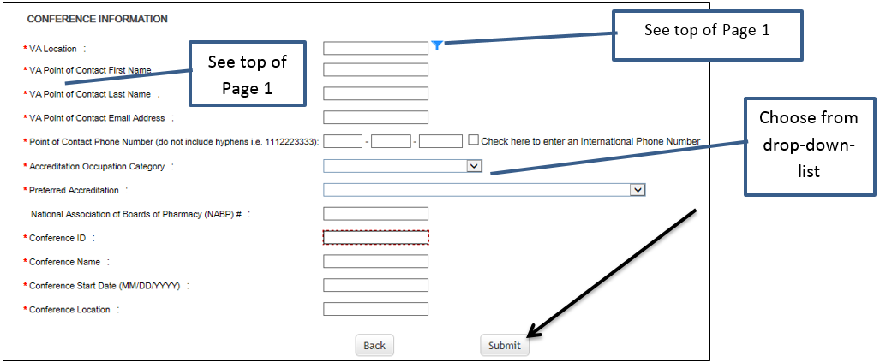

*Note: If there were any errors identified after selecting* ***SUBMIT****, you must fix those and then select* ***SUBMIT*** *again. Keep making corrections until you succeed.*

1. Once any errors have been corrected, you should see the **Congratulations** screen. At this point you should make note of your TMS Username (which will be the Email Address that you entered). Once you click “Continue”, the following User ID message will display. Click ***Continue*** to proceed.

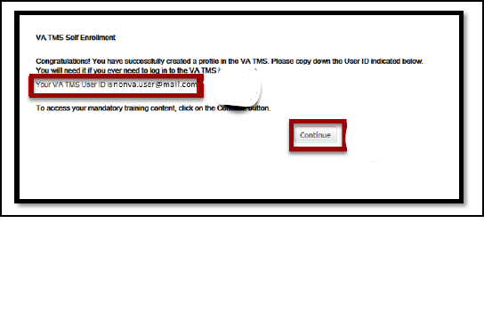

1. After 20 minutes have passed, please return to <https://www.tms.va.gov/SecureAuth35/> and enter your Username and click Submit. TMS requires a double authentication to access. After you enter your User name and submit you will need to get a passcode to access. The passcode will be mailed to the email address you provided above.

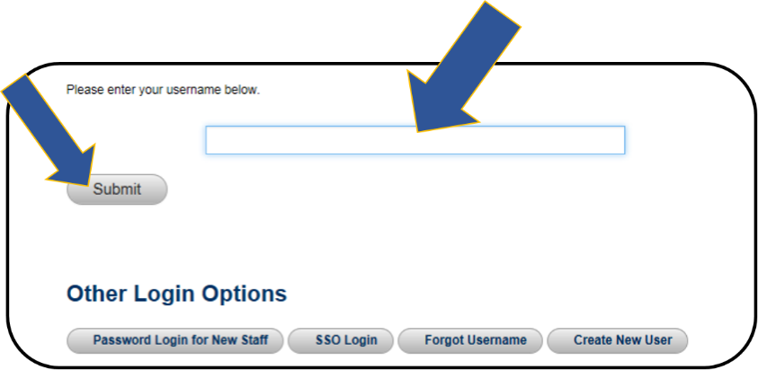

1. Once your Passcode arrives, enter it using your keyboard, or the on-screen number pad, and click Submit.

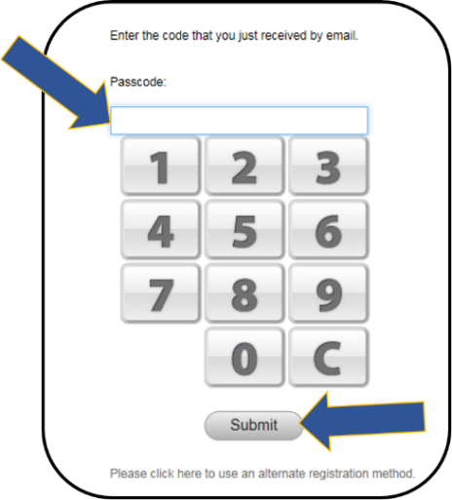

1. You will be asked to select and provide answers to two security questions. These will be used if you need to reset your TMS password.

Snapshot of the Set Security Questions screen where you must select two questions and enter and re-enter the answers to these questions. After the questions and answer responses, there is a SAVE button

After selecting your questions and entering your answers, select the **SAVE** button.

At this point, you have now created your TMS User Profile

**KEEP TRACK OF YOUR TMS LOGIN AND PASSWORD. YOU WILL NEED IT THROUGHOUT THIS PROCESS**

**STEP 2: Registering for the program in TMS.**

1. After logging in to TMS, you will see this screen.
   * Click on **Home** and select **Learning**

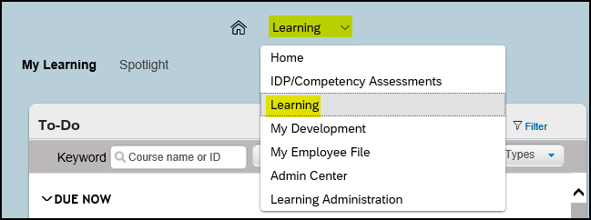

1. You will be taken to this screen:

* Locate Find Learning
* Enter the Conference ID number located at the beginning of this document
* Click on **Go**

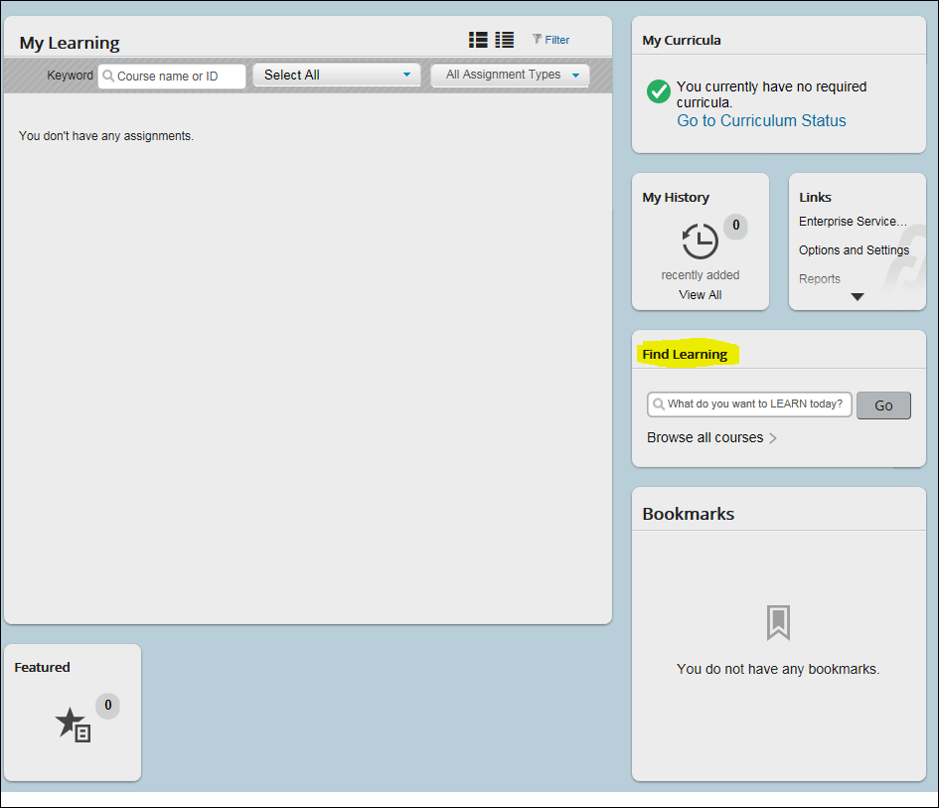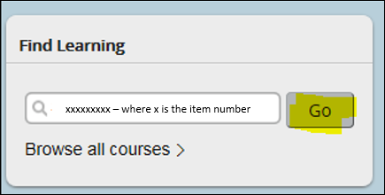

1. The screen will be the results of your search – **this is an example below**

* Click on **See Offerings** to see available offerings
* Click on **Register Now**

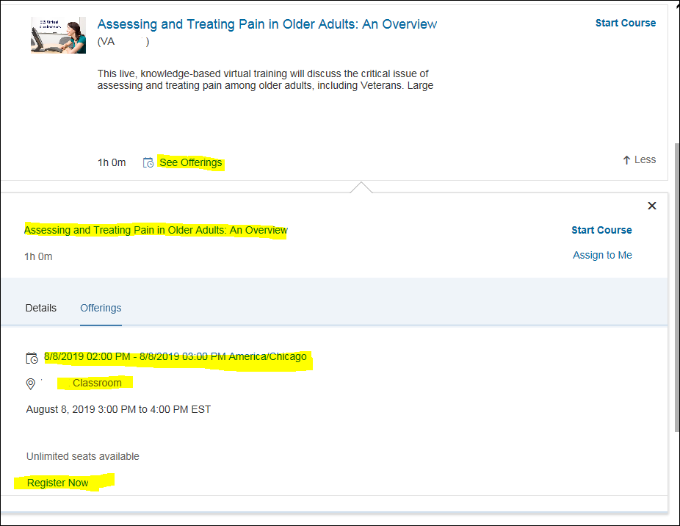

1. On this screen

* Select your accreditation type from the dropdown
* Add any Comments if needed
* Click on **Confirm**

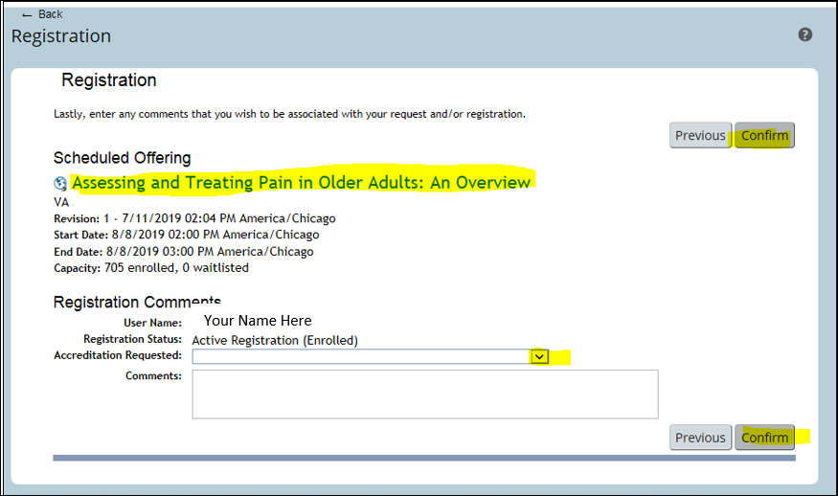

1. You will see this page confirming your registration:

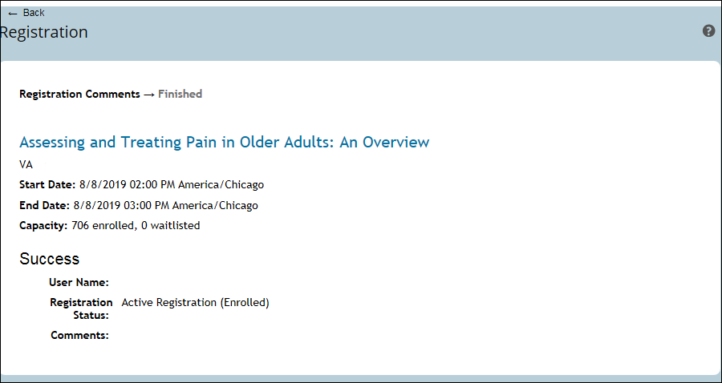

1. Go back to the Learning Page by clicking on My Learning:

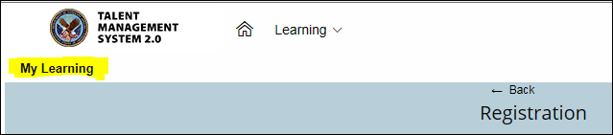

1. See the program and registration on the Learning Plan:

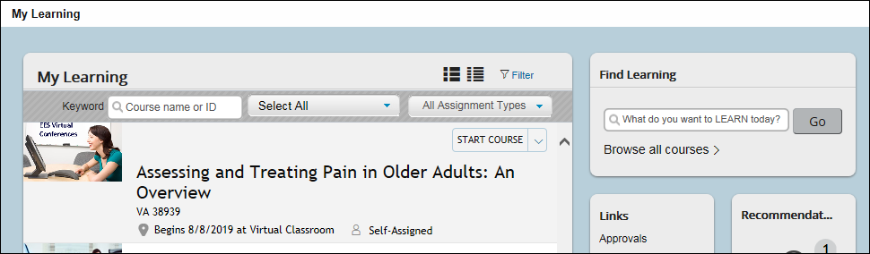

Notes:

* If you have any problems with registration contact the VA Contact person listed at the top of this document
* The program shown here is an example. Individual program and offering information will vary
* At the program, wait for more instructions on completing the program

**STEP 3: After the end of the program. Verify and evaluate the education WITHIN 30 DAYS to obtain your accredited certificate**

1. About one week after the program, log in to the TMS homepage (<https://www.tms.va.gov/SecureAuth35/>). Sign in using your user ID identified in **F** (above). You will also need to do **G** and **H** again. If you want to print your certificate, be sure your computer is connected to a printer.

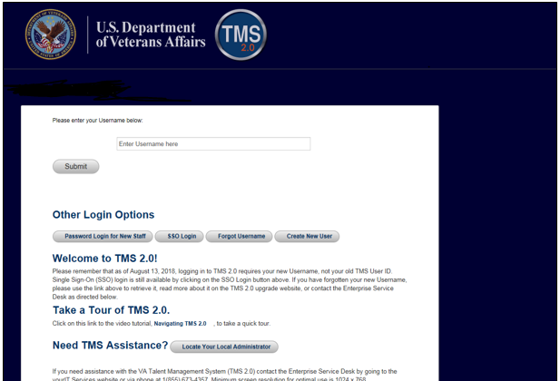

1. The education course you attended should be on the To-Do List. Click on the name.

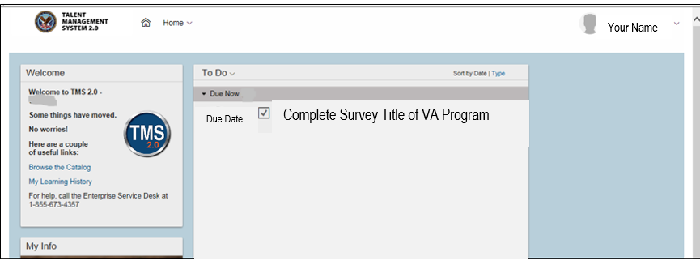

Click on “Complete Survey”, complete and submit it.

1. After the Survey (evaluation) has been received, you will be taken to a new page. On this page click on the “My History” tile.

Click on “View All”.

Hover the cursor over the program title click on “View Details” in the popup window that appears. DO NOT click on the “Print Certificate” here.

In the Completed Work Details screen, you should see a section named “Accreditation Details.”

Click the “Print Accredited Certificate” button next to your requested Accreditation (ACCME, ANCC, etc.)

Your Accredited certificate should appear on the screen for you to save or print.